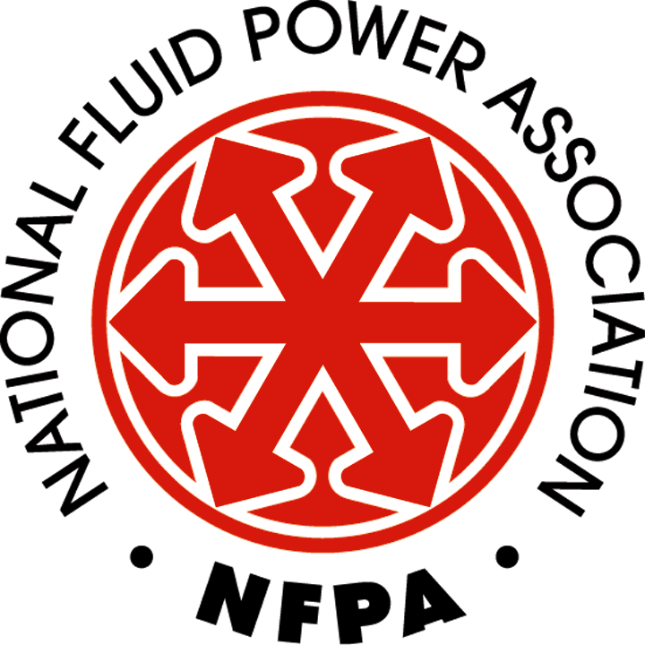 | Fluid Power Education Manager  Job Description as of October 20, 2014

Job Overview
In accordance with NFPA policies and procedures, the Fluid Power Education Manager:
- Communications: At least once every two weeks, contributes relevant content in the form of posts and articles to NFPA News and other appropriate NFPA web properties
- Fluid Power Locator: Coordinate member and machine/equipment builder interaction with the NFPA member directory and the fluid power product locator
- Fluid Power Marketing Committee: Serves as the staff liaison to the NFPA Fluid Power Marketing Committee
- Standards Education: Educate machine/equipment builders about to use of standards that can ease their use of fluid power
- Technical Board: Serves as the staff liaison to the NFPA Technical Board
- Trade Show Education: Organize fluid power educational events at customer market trade shows
- U.S. TAG: Serves as Secretary to the U.S. Technical Advisory Group to provide U.S. input to the development of the international standards
- Website Marketing: Develop messages about fluid power’s competitive advantages in key customer markets and use them to build content for NFPA website

Reporting Structure
The Fluid Power Education Manager reports to the Chief Executive Officer (CEO).

Essential Job Functions
Include the following. Other duties may be assigned by the Chief Executive Officer (CEO).
- Communications: At least once every two weeks, contributes relevant content in the form of posts and articles to NFPA News and other appropriate NFPA web properties
- Fluid Power Locator: Coordinate member and machine/equipment builder interaction with the NFPA member directory and the fluid power product locator
  - Establish and coordinate an on-going process to engage NFPA members in the review and update of their member directory/product locator information.
  - Connect the member directory/product locator to all the technology marketing programs of the NFPA.
  - Establish a mechanism to identify visitors to the member directory/product locator and track their viewing habits.
  - Define, track and report performance metrics to NFPA members.
- Fluid Power Marketing Committee: Serves as the staff liaison to the NFPA Fluid Power Marketing Committee
- Actively recruit members to serve on the committee.
- Work with committee leadership to ensure a regular succession of skilled committee leaders.
- Provide agendas, maintain minutes, and provide guidance to committee concerning administrative issues and implementation matters.
- Manage and coordinate committee programs.
- Standards Education: Educate machine/equipment builders about to use of standards that can ease their use of fluid power
- Prepare educational content and obtain speakers for conferences, seminars and webcast productions.
- Technical Board: Serves as the staff liaison to the NFPA Technical Board
- Seek NFPA member participation for this Board. Maintain a roster of members and officers.
- Develop an agenda for the annual meeting in consultation with the Board chair
- Issue notification of the annual meeting
- Take minutes at the meeting and distribute them to the members
- Discharge the actions required from the meeting
- Conduct elections to fill Board Officer positions
- Maintain a list of NFPA standards and the dates from their renewal or withdrawal
- Trade Show Education: Organize fluid power educational events at customer market trade shows
  - Manage NFPA’s involvement in planning, promoting and coordinating the Energy Efficient Hydraulics and Pneumatics Conference.
- U.S. TAG: Serves as Secretary to the U.S. Technical Advisory Group to provide U.S. input to the development of the international standards
  - Increase participation on the U.S. TAG and its committees, including:
    - Annually, submit a request to the technical representative of each NFPA member company for people they wish to participate in U.S. TAG activities, and to which committees.
    - Submit a similar request to other organizations with an interest in fluid power and solicit their participation.
    - Also publish the request in appropriate publications and ask interested parties to participate in the U.S. TAG.
    - Record necessary information on each applicant.
    - Issue ballots to the U.S. TAG membership for acceptance of all new applicants.
    - Maintain a roster of participants in each TAG committee, with addresses for communication.
  - Determine the U.S. position on all ISO ballots, including:
    - Collect all of the ballots issued from ISO, list their due dates and distribute them to the proper TAG committees. Send follow-ups to remind members to vote.
    - With the TAG chair, organize TAG teleconferences to correspond with the ballot due dates so that members have an opportunity to discuss the issues.
    - Take minutes at the TAG teleconferences, review with the chair, and distribute to members.
    - Collect the ballot results and comments made, and discuss them with the TAG chair to conclude a U.S. response. Distribute this conclusion to the TAG members for a final review.
    - Conduct teleconferences to resolve any objections from the final review.
    - Submit the ballot results and any comments to ANSI for casting the ballots on behalf of the U.S. Obtain a confirmation
  - Organize meetings of the U.S. TAG and its committees when needed.
  - Be familiar with and adhere to the ANSI Operating Procedures for U.S. TAGs, and the version adapted from TC 131.
  - Keep a roster of the TAG officers and chairs, their terms of office, and conduct elections for these positions as necessary.
- Website Marketing: Develop messages about fluid power’s competitive advantages in key customer markets and use them to build content for NFPA website
  - Work with Fluid Power Marketing Committee to review and maintain information on the NFPA website about the definition, uses and advantages of fluid power.
  - Continually crowdsource nominations for the NFPA Innovation Award and use the nominees and winner to refresh information on the NFPA website about fluid power applications and case studies.
  - Oversee application, selection and promotion of the NFPA Innovation Award.
  - Establish a mechanism to identify visitors to this section of the NFPA website and track their viewing habits.
  - Define, track and report performance metrics to NFPA members.
- Other
- Act as a technical resource to address and resolve inquiries and problems related to fluid power technology and standards.
- Answer incoming telephone calls on general line, and transferred calls to "operator" as needed.
- Provide on-site assistance, as needed, at NFPA conferences, workshops, seminars, tradeshows, etc.

Specific Knowledge and Skill Sets
The requirements described here are representative of the knowledge, skills, and/or abilities that must be met by an employee to successfully perform the essential functions of this job. Reasonable accommodations may be made to enable individuals with disabilities to perform the essential functions.
- Social Media Skills
  - Proven ability to use social networking software and websites in a business setting.
  - Expertise in content strategy specific to different social media sites.
  - Ability to track social media metrics and report on KPIs.
  - Blogging experience.
- Language Skills
  - Ability to read and interpret technical standards relevant to the fluid power industry.
  - Ability to read, analyze, and interpret government regulations, technical journals, legal documents, financial reports, business periodicals and operating instructions.
  - Ability to effectively communicate with NFPA members, members of the business community, public groups, vendors, customers and other NFPA employees.
  - Ability to write and prepare educational materials, marketing materials, business correspondence, activity reports, and instruction manuals.
  - Ability to write for social media sites in accordance with the particular culture of each site.
- Mathematical Skills
- Ability to work with, and understand, calculations and formulas typically used for general business, financial and economic statistics, such as calculations and methods for weighting, establishing trends and correlations.
  - Ability to compute and apply interest, discounts, commissions, fractions, percentages, ratios and proportions to practical situations.
- Ability to add, subtract, multiply, and divide in all units of measure, using whole numbers, common fractions, and decimals.
- Computer Skills
- Ability to use Windows PC computer platform.
- Ability to work with peripherals such as printers, scanners, digital cameras and projectors.
- Ability to use general Microsoft Office software, i.e., Word, Excel, PowerPoint.
- Ability to use social networking software and websites.
- Ability to understand basic database layout and functions.
- Other
  - Knowledge of other cultures and an ability to work with people from a variety of countries and backgrounds.
  - Ability to operate a variety of standard business machines, such as a keyboard, calculator, telephone, FAX, photocopier, etc.
- Accurate typing skills.

General Expectations
All NFPA employees are expected to:
- Lead the organization in creating new value for the members.
- Demonstrate enthusiasm about growing as individuals and about growing the organization.
- Act with honesty and professionalism in all relationships.
- Work together to deliver exceptional service.
- Perform each of their essential job functions satisfactorily.
- Maintain competency in their specific knowledge and skill sets.
- Utilize proven communication, organizational, and critical thinking skills.
- Consistently produce high-quality work within deadlines.
- Remain current with business technology and changes in the fluid power industry.

Education and Experience
Requires a bachelor's degree in a job related major and five to seven years of related experience; or other equivalent combination of education and experience.

Certificates, Licenses and Registrations
Requires a valid driver’s license and passport.

Physical Demands
The physical demands described here are representative of those that must be met by an employee to successfully perform the essential functions of this job. Reasonable accommodations may be made to enable individuals with disabilities to perform the essential functions.
- Ability to sit, stand and walk.
- Ability to reach with hands and arms, stoop, kneel, crouch, and crawl.
- Ability to communicate and study by seeing, hearing, talking, and by using a computer and telephone. Specific vision abilities required by this job include close vision, distance vision, color vision, peripheral vision, depth perception, and ability to adjust focus.
- Ability to lift and/or move up to 25 pounds.

Work Environment
The work environment characteristics described here are representative of those an employee encounters while performing the essential functions of this job. Reasonable accommodations may be made to enable individuals with disabilities to perform the essential functions.
- The employee is occasionally exposed to outside weather conditions and risk of electrical shock.
- The employee occasionally performs work-related national and international travel.
- The employee is occasionally required to work evenings and weekends.
- The noise level in the work environment is usually moderate.

Supervisor Approval: Date:

Employee Acceptance: Date:

